SET-I
1. What are the basic differences between relational database and HDFS?
Here are the key differences between HDFS and relational database:
RDBMS vs. Hadoop
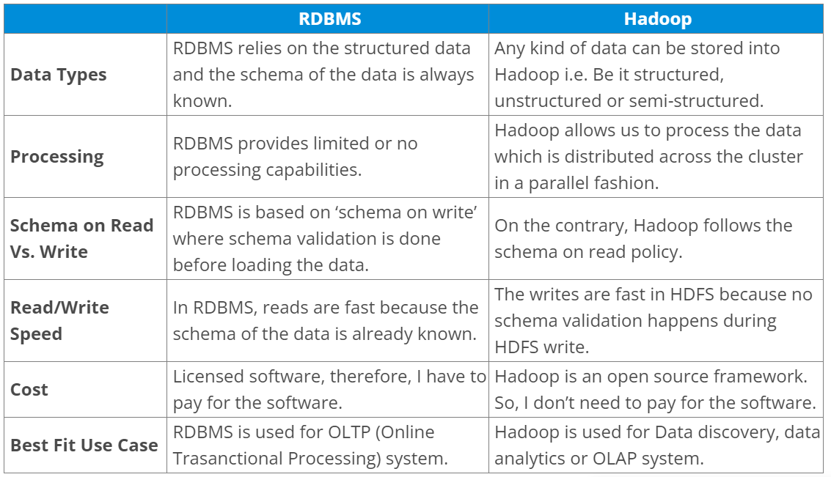
2. Explain “Big Data” and what are five V’s of Big Data?
“Big data” is the term for a collection of large and complex data sets, that makes it difficult to process using relational database management tools or traditional data processing applications. It is difficult to capture, curate, store, search, share, transfer, analyse, and visualize Big data. Big Data has emerged as an opportunity for companies. Now they can successfully derive value from their data and will have a distinct advantage over their competitors with enhanced business decisions making capabilities. Learn more about Big Data and its applications from the Azure Data Engineering Course in Bangalore.
Volume: The volume represents the amount of data which is growing at an exponential rate i.e. in Petabytes and Exabytes.
Velocity: Velocity refers to the rate at which data is growing, which is very fast. Today, yesterday’s data are considered as old data. Nowadays, social media is a major contributor to the velocity of growing data.
Variety: Variety refers to the heterogeneity of data types. In another word, the data which are gathered has a variety of formats like videos, audios, csv, etc. So, these various formats represent the variety of data.
Veracity: Veracity refers to the data in doubt or uncertainty of data available due to data inconsistency and incompleteness. Data available can sometimes get messy and may be difficult to trust. With many forms of big data, quality and accuracy are difficult to control. The volume is often the reason behind for the lack of quality and accuracy in the data.
Value: It is all well and good to have access to big data but unless we can turn it into a value it is useless. By turning it into value I mean, Is it adding to the benefits of the organizations? Is the organization working on Big Data achieving high ROI (Return On Investment)? Unless, it adds to their profits by working on Big Data, it is useless.

3. What is Hadoop and its components.
When “Big Data” emerged as a problem, Apache Hadoop evolved as a solution to it. Apache Hadoop is a framework which provides us various services or tools to store and process Big Data. It helps in analysing Big Data and making business decisions out of it, which can’t be done efficiently and effectively using traditional systems.
Storage unit– HDFS (Name Node, Data Node)
Processing framework– YARN (Resource Manager, Node Manager)
4. What are HDFS and YARN?
HDFS (Hadoop Distributed File System) is the storage unit of Hadoop. It is responsible for storing different kinds of data as blocks in a distributed environment. It follows master and slave topology.
Name Node: Name Node is the master node in the distributed environment and it maintains the metadata information for the blocks of data stored in HDFS like block location, replication factors etc.
Data Node: Data Nodes are the slave nodes, which are responsible for storing data in the HDFS. Name Node manages all the Data Nodes.
YARN (Yet Another Resource Negotiator) is the processing framework in Hadoop, which manages resources and provides an execution environment to the processes.
Resource Manager: It receives the processing requests, and then passes the parts of requests to corresponding Node Managers accordingly, where the actual processing takes place. It allocates resources to applications based on the needs.
Node Manager: Node Manager is installed on every Data Node and it is responsible for the execution of the task on every single Data Node.

5. Tell me about the various Hadoop daemons and their roles in a Hadoop cluster.
Generally, approach this question by first explaining the HDFS daemons i.e. Name Node, Data Node and Secondary Name Node, and then moving on to the YARN daemons i.e. Resource Manager and Node Manager, and lastly explaining the JobHistoryServer.
Name Node: It is the master node which is responsible for storing the metadata of all the files and directories. It has information about blocks, that make a file, and where those blocks are in the cluster.
Data node: It is the slave node that contains the actual data.
Secondary Name Node: It periodically merges the changes (edit log) with the FsImage (Filesystem Image), present in the Name Node. It stores the modified FsImage into persistent storage, which can be used in case of failure of Name Node.
Resource Manager: It is the central authority that manages resources and schedule applications running on top of YARN.
Node Manager: It runs on slave machines, and is responsible for launching the application’s containers (where applications execute their part), monitoring their resource usage (CPU, memory, disk, network) and reporting these to the Resource Manager.
Job History Server: It maintains information about MapReduce jobs after the Application Master terminates.
6. Compare HDFS with Network Attached Storage (NAS).
In this question, first explain NAS and HDFS, and then compare their features as follows:
Network-attached storage (NAS) is a file-level computer data storage server connected to a computer network providing data access to a heterogeneous group of clients. NAS can either be a hardware or software which provides services for storing and accessing files. Whereas Hadoop Distributed File System (HDFS) is a distributed filesystem to store data using commodity hardware.
In HDFS Data Blocks are distributed across all the machines in a cluster. Whereas in NAS data is stored on a dedicated hardware.
HDFS is designed to work with MapReduce paradigm, where computation is moved to the data. NAS is not suitable for MapReduce since data is stored separately from the computations.
HDFS uses commodity hardware which is cost-effective, whereas a NAS is a high-end storage devices which includes high cost.
7. List the difference between Hadoop 1 and Hadoop 2.
This is an important question and while answering this question, we have to mainly focus on two points i.e. Passive Name Node and YARN architecture.

In Hadoop 1.x, “Name Node” is the single point of failure. In Hadoop 2.x, we have Active and Passive “Name Nodes”. If the active “Name Node” fails, the passive “Name Node” takes charge. Because of this, high availability can be achieved in Hadoop 2.x.
Also, in Hadoop 2.x, YARN provides a central resource manager. With YARN, you can now run multiple applications in Hadoop, all sharing a common resource. MRV2 is a particular type of distributed application that runs the MapReduce framework on top of YARN. Other tools can also perform data processing via YARN, which was a problem in Hadoop 1.x.
Hadoop 1.x vs. Hadoop 2.x
Hadoop 1.x Hadoop 2.x
Passive Name Node Name Node is a Single Point of Failure Active & Passive Name Node
Processing MRV1 (Job Tracker & Task Tracker) MRV2/YARN (Resource Manager & Node Manager)
8. What are active and passive “Name Nodes”?
In HA (High Availability) architecture, we have two Name Nodes – Active “Name Node” and Passive “Name Node”.

Active “NameNode” is the “NameNode” which works and runs in the cluster.
Passive “NameNode” is a standby “NameNode”, which has similar data as active “NameNode”.
When the active “NameNode” fails, the passive “NameNode” replaces the active “NameNode” in the cluster. Hence, the cluster is never without a “NameNode” and so it never fails.

9. Why does one remove or add nodes in a Hadoop cluster frequently?
One of the most attractive features of the Hadoop framework is its utilization of commodity hardware. However, this leads to frequent “Data Node” crashes in a Hadoop cluster. Another striking feature of Hadoop Framework is the ease of scale in accordance with the rapid growth in data volume. Because of these two reasons, one of the most common tasks of a Hadoop administrator, as learned from the Hadoop Admin Training, is to commission (Add) and decommission (Remove) “Data Nodes” in a Hadoop Cluster.
10. What happens when two clients try to access the same file in the HDFS?
HDFS supports exclusive write only.
When the first client contacts the “NameNode” to open the file for writing, the “NameNode” grants a lease to the client to create this file. When the second client tries to open the same file for writing, the “NameNode” will notice that the lease for the file is already granted to another client, and will reject the open request for the second client.

11. How does Name Node tackle Data Node failures?
Name Node periodically receives a Heartbeat (signal) from each of the Data Node in the cluster, which implies Data Node is functioning properly.
A block report contains a list of all the blocks on a Data Node. If a Data Node fails to send a heartbeat message, after a specific period of time it is marked dead.
The Name Node replicates the blocks of dead node to another Data Node using the replicas created earlier.
12. What will you do when Name Node is down?
The Name Node recovery process involves the following steps to make the Hadoop cluster up and running:
Use the file system metadata replica (FsImage) to start a new NameNode.
Then, configure the DataNodes and clients so that they can acknowledge this new NameNode, that is started.
Now the new NameNode will start serving the client after it has completed loading the last checkpoint FsImage (for metadata information) and received enough block reports from the DataNodes.
Whereas, on large Hadoop clusters this NameNode recovery process may consume a lot of time and this becomes even a greater challenge in the case of the routine maintenance. Therefore, we have HDFS High Availability Architecture which is covered in the HA architecture blog.

13. What is a checkpoint?
In brief, “Checkpointing” is a process that takes an FsImage, edit log and compacts them into a new FsImage. Thus, instead of replaying an edit log, the Name Node can load the final in-memory state directly from the FsImage. This is a far more efficient operation and reduces Name Node startup time. Checkpointing is performed by Secondary Name Node.

14. How is HDFS fault tolerant?
When data is stored over HDFS, Name Node replicates the data to several Data Node. The default replication factor is 3. You can change the configuration factor as per your need. If a Data Node goes down, the Name Node will automatically copy the data to another node from the replicas and make the data available. This provides fault tolerance in HDFS.

15. Can Name Node and Data Node be a commodity hardware?
The smart answer to this question would be, Data Nodes are commodity hardware like personal computers and laptops as it stores data and are required in a large number. But from your experience, you can tell that, Name Node is the master node and it stores metadata about all the blocks stored in HDFS. It requires high memory (RAM) space, so Name Node needs to be a high-end machine with good memory space.

16. Why do we use HDFS for applications having large data sets and not when there are a lot of small files?
HDFS is more suitable for large amounts of data sets in a single file as compared to small amount of data spread across multiple files. As you know, the NameNode stores the metadata information regarding the file system in the RAM. Therefore, the amount of memory produces a limit to the number of files in my HDFS file system. In other words, too many files will lead to the generation of too much metadata. And, storing these metadata in the RAM will become a challenge. As a thumb rule, metadata for a file, block or directory takes 150 bytes.

17. How do you define “block” in HDFS? What is the default block size in Hadoop 1 and in Hadoop 2? Can it be changed?
Blocks are the nothing but the smallest continuous location on your hard drive where data is stored. HDFS stores each as blocks, and distribute it across the Hadoop cluster. Files in HDFS are broken down into block-sized chunks, which are stored as independent units.

Hadoop 1 default block size: 64 MB
Hadoop 2 default block size: 128 MB
Yes, blocks can be configured. The dfs.block.size parameter can be used in the hdfs-site.xml file to set the size of a block in a Hadoop environment.
18. What does ‘jps’ command do?
The ‘jps’ command helps us to check if the Hadoop daemons are running or not. It shows all the Hadoop daemons i.e., name node, data node, resource manager, node manager etc. that are running on the machine.
19. How do you define “Rack Awareness” in Hadoop?
Rack Awareness is the algorithm in which the “Name Node” decides how blocks and their replicas are placed, based on rack definitions to minimize network traffic between “Data Nodes” within the same rack. Let’s say we consider replication factor 3 (default), the policy is that “for every block of data, two copies will exist in one rack, third copy in a different rack”. This rule is known as the “Replica Placement Policy”.
To know rack awareness in more detail, refer to the HDFS architecture blog.
20. What is “speculative execution” in Hadoop?
If a node appears to be executing a task slower, the master node can redundantly execute another instance of the same task on another node. Then, the task which finishes first will be accepted and the other one is killed. This process is called “speculative execution.”

21. How can I restart “Name Node” or all the daemons in Hadoop?
This question can have two answers, we will discuss both the answers. We can restart NameNode by following methods:

You can stop the NameNode individually using. /sbin /hadoop-daemon.sh stop namenode command and then start the NameNode using. /sbin/hadoop-daemon.sh start namenode command.
To stop and start all the daemons, use. /sbin/stop-all.sh and then use ./sbin/start-all.sh command which will stop all the daemons first and then start all the daemons.
These script files reside in the sbin directory inside the Hadoop directory.

22. What is the difference between an “HDFS Block” and an “Input Split”?
The “HDFS Block” is the physical division of the data while “Input Split” is the logical division of the data. HDFS divides data in blocks for storing the blocks together, whereas for processing, MapReduce divides the data into the input split and assign it to mapper function.
23. Name the three modes in which Hadoop can run.
The three modes in which Hadoop can run are as follows:

Standalone (local) mode: This is the default mode if we don’t configure anything. In this mode, all the components of Hadoop, such NameNode, DataNode, ResourceManager, and NodeManager, run as a single Java process. This uses the local filesystem.
Pseudo-distributed mode: A single-node Hadoop deployment is considered as running Hadoop system in pseudo-distributed mode. In this mode, all the Hadoop services, including both the master and the slave services, were executed on a single compute node.
Fully distributed mode: A Hadoop deployment in which the Hadoop master and slave services run on separate nodes, are stated as fully distributed mode.
24. What is “MapReduce”? What is the syntax to run a “MapReduce” program?
It is a framework/a programming model that is used for processing large data sets over a cluster of computers using parallel programming. The syntax to run a MapReduce program is hadoop_jar_file.jar /input_path /output_path.

If you have any doubt in MapReduce or want to revise your concepts you can refer this MapReduce tutorial.

25. What are the main configuration parameters in a “MapReduce” program?
The main configuration parameters which users need to specify in “MapReduce” framework are:
Job’s input locations in the distributed file system
Job’s output location in the distributed file system
Input format of data
Output format of data
Class containing the map function
Class containing the reduce function
JAR file containing the mapper, reducer and driver classes
26. State the reason why we can’t perform “aggregation” (addition) in mapper? Why do we need the “reducer” for this?
This answer includes many points, so we will go through them sequentially.

We cannot perform “aggregation” (addition) in mapper because sorting does not occur in the “mapper” function. Sorting occurs only on the reducer side and without sorting aggregation cannot be done.
During “aggregation”, we need the output of all the mapper functions which may not be possible to collect in the map phase as mappers may be running on the different machine where the data blocks are stored.
And lastly, if we try to aggregate data at mapper, it requires communication between all mapper functions which may be running on different machines. So, it will consume high network bandwidth and can cause network bottlenecking.
27. What is the purpose of “RecordReader” in Hadoop?
The “InputSplit” defines a slice of work, but does not describe how to access it. The “RecordReader” class loads the data from its source and converts it into (key, value) pairs suitable for reading by the “Mapper” task. The “RecordReader” instance is defined by the “Input Format”.

28. Explain “Distributed Cache” in a “MapReduce Framework”.
Distributed Cache can be explained as, a facility provided by the MapReduce framework to cache files needed by applications. Once you have cached a file for your job, Hadoop framework will make it available on each and every data nodes where you map/reduce tasks are running. Then you can access the cache file as a local file in your Mapper or Reducer job.

29. How do “reducers” communicate with each other?
This is a tricky question. The “MapReduce” programming model does not allow “reducers” to communicate with each other. “Reducers” run in isolation.

30. What does a “MapReduce Partitioner” do?
A “MapReduce Partitioner” makes sure that all the values of a single key go to the same “reducer”, thus allowing even distribution of the map output over the “reducers”. It redirects the “mapper” output to the “reducer” by determining which “reducer” is responsible for the particular key.

31. How will you write a custom partitioner?
Custom partitioner for a Hadoop job can be written easily by following the below steps:

Create a new class that extends Partitioner Class
Override method – getPartition, in the wrapper that runs in the MapReduce.
Add the custom partitioner to the job by using method set Partitioner or add the custom partitioner to the job as a config file.
32. What is a “Combiner”?
A “Combiner” is a mini “reducer” that performs the local “reduce” task. It receives the input from the “mapper” on a particular “node” and sends the output to the “reducer”. “Combiners” help in enhancing the efficiency of “MapReduce” by reducing the quantum of data that is required to be sent to the “reducers”.

33. What do you know about “SequenceFileInputFormat”?
“SequenceFileInputFormat” is an input format for reading within sequence files. It is a specific compressed binary file format which is optimized for passing the data between the outputs of one “MapReduce” job to the input of some other “MapReduce” job.

Sequence files can be generated as the output of other MapReduce tasks and are an efficient intermediate representation for data that is passing from one MapReduce job to another.

34. What are the benefits of Apache Pig over MapReduce?
Apache Pig is a platform, used to analyze large data sets representing them as data flows developed by Yahoo. It is designed to provide an abstraction over MapReduce, reducing the complexities of writing a MapReduce program.
Pig Latin is a high-level data flow language, whereas MapReduce is a low-level data processing paradigm.
Without writing complex Java implementations in MapReduce, programmers can achieve the same implementations very easily using Pig Latin.
Apache Pig reduces the length of the code by approx 20 times (according to Yahoo). Hence, this reduces the development period by almost 16 times.
Pig provides many built-in operators to support data operations like joins, filters, ordering, sorting etc. Whereas to perform the same function in MapReduce is a humongous task.
Performing a Join operation in Apache Pig is simple. Whereas it is difficult in MapReduce to perform a Join operation between the data sets, as it requires multiple MapReduce tasks to be executed sequentially to fulfill the job.
In addition, pig also provides nested data types like tuples, bags, and maps that are missing from MapReduce.
35. What are the different data types in Pig Latin?
Pig Latin can handle both atomic data types like int, float, long, double etc. and complex data types like tuple, bag and map.
Atomic data types: Atomic or scalar data types are the basic data types which are used in all the languages like string, int, float, long, double, char[], byte[].
Complex Data Types: Complex data types are Tuple, Map and Bag.
36. What are the different relational operations in “Pig Latin” you worked with?
Different relational operators are:

for each
order by
filters
group
distinct
join
limit

37. What is a UDF?
If some functions are unavailable in built-in operators, we can programmatically create User Defined Functions (UDF) to bring those functionalities using other languages like Java, Python, Ruby, etc. and embed it in Script file.
Apache Hive Interview Questions
38. What is “SerDe” in “Hive”?
Apache Hive is a data warehouse system built on top of Hadoop and is used for analyzing structured and semi-structured data developed by Facebook. Hive abstracts the complexity of Hadoop MapReduce.
The “SerDe” interface allows you to instruct “Hive” about how a record should be processed. A “SerDe” is a combination of a “Serializer” and a “Deserializer”. “Hive” uses “SerDe” (and “FileFormat”) to read and write the table’s row.
39. Can the default “Hive Metastore” be used by multiple users (processes) at the same time?
“Derby database” is the default “Hive Metastore”. Multiple users (processes) cannot access it at the same time. It is mainly used to perform unit tests.
40. What is the default location where “Hive” stores table data?
The default location where Hive stores table data is inside HDFS in /user/hive/warehouse.
41. What is Apache HBase?
HBase is an open source, multidimensional, distributed, scalable and a NoSQL database written in Java. HBase runs on top of HDFS (Hadoop Distributed File System) and provides BigTable (Google) like capabilities to Hadoop. It is designed to provide a fault-tolerant way of storing the large collection of sparse data sets. HBase achieves high throughput and low latency by providing faster Read/Write Access on huge datasets.
42. What are the components of Apache HBase?
HBase has three major components, i.e. HMaster Server, HBase RegionServer and Zookeeper.
Region Server: A table can be divided into several regions. A group of regions is served to the clients by a Region Server.
HMaster: It coordinates and manages the Region Server (similar as NameNode manages DataNode in HDFS).
ZooKeeper: Zookeeper acts like as a coordinator inside HBase distributed environment. It helps in maintaining server state inside the cluster by communicating through sessions.
43. What are the components of Region Server?
The components of a Region Server are:
WAL: Write Ahead Log (WAL) is a file attached to every Region Server inside the distributed environment. The WAL stores the new data that hasn’t been persisted or committed to the permanent storage.
Block Cache: Block Cache resides in the top of Region Server. It stores the frequently read data in the memory.
MemStore: It is the write cache. It stores all the incoming data before committing it to the disk or permanent memory. There is one MemStore for each column family in a region.
HFile: HFile is stored in HDFS. It stores the actual cells on the disk.
44. Explain “WAL” in HBase?
Write Ahead Log (WAL) is a file attached to every Region Server inside the distributed environment. The WAL stores the new data that hasn’t been persisted or committed to the permanent storage. It is used in case of failure to recover the data sets.

45. Mention the differences between “HBase” and “Relational Databases”?
HBase is an open source, multidimensional, distributed, scalable and a NoSQL database written in Java. HBase runs on top of HDFS and provides BigTable like capabilities to Hadoop. Let us see the differences between HBase and relational database.

HBase vs. Relational Database
HBase Relational Database
It is schema-less It is schema-based database
It is column-oriented data store It is row-oriented data store
It is used to store de-normalized data It is used to store normalized data
It contains sparsely populated tables It contains thin tables
Automated partitioning is done is HBase There is no such provision or built-in support for partitioning

46. What is Apache Spark?
The answer to this question is, Apache Spark is a framework for real-time data analytics in a distributed computing environment. It executes in-memory computations to increase the speed of data processing.

It is 100x faster than MapReduce for large-scale data processing by exploiting in-memory computations and other optimizations.

47. Can you build “Spark” with any particular Hadoop version?
Yes, one can build “Spark” for a specific Hadoop version. Check out this blog to learn more about building YARN and HIVE on Spark.
48. Define RDD.
RDD is the acronym for Resilient Distribution Datasets – a fault-tolerant collection of operational elements that run parallel. The partitioned data in RDD are immutable and distributed, which is a key component of Apache Spark.
49. What is Apache ZooKeeper and Apache Oozie?
Apache Zookeeper coordinates with various services in a distributed environment. It saves a lot of time by performing synchronization, configuration maintenance, grouping, and naming.

Apache Oozie is a scheduler that schedules Hadoop jobs and binds them together as one logical work. There are two kinds of Oozie jobs:

Oozie Workflow: These are the sequential set of actions to be executed. You can assume it as a relay race. Where each athlete waits for the last one to complete his part.
Oozie Coordinator: These are the Oozie jobs that are triggered when the data is made available to it. Think of this as the response-stimuli system in our body. In the same manner, as we respond to an external stimulus, an Oozie coordinator responds to the availability of data and it rests otherwise.
50. How do you configure an “Oozie” job in Hadoop?
“Oozie” is integrated with the rest of the Hadoop stack supporting several types of Hadoop jobs such as “Java MapReduce”, “Streaming MapReduce”, “Pig”, “Hive” and “Sqoop”.

SET-II
HDFS Interview Questions - HDFS
1. What are the different vendor-specific distributions of Hadoop?
The different vendor-specific distributions of Hadoop are Cloudera, MAPR, Amazon EMR, Microsoft Azure, IBM InfoSphere, and Hortonworks (Cloudera).

2. What are the different Hadoop configuration files?
The different Hadoop configuration files include:
hadoop-env.sh
mapred-site.xml
core-site.xml
yarn-site.xml
hdfs-site.xml
Master and Slaves

3. What are the three modes in which Hadoop can run?
The three modes in which Hadoop can run are :
Standalone mode: This is the default mode. It uses the local FileSystem and a single Java process to run the Hadoop services.
Pseudo-distributed mode: This uses a single-node Hadoop deployment to execute all Hadoop services.
Fully-distributed mode: This uses separate nodes to run Hadoop master and slave services.

4. What are the differences between regular File System and HDFS?
Regular Filesystem: In regular Filesystem, data is maintained in a single system. If the machine crashes, data recovery is challenging due to low fault tolerance. Seek time is more and hence it takes more time to process the data.
HDFS: Data is distributed and maintained on multiple systems. If a Data Node crashes, data can still be recovered from other nodes in the cluster. Time taken to read data is comparatively more, as there is local data read to the disc and coordination of data from multiple systems.

5. Why is HDFS fault-tolerant?
HDFS is fault-tolerant because it replicates data on different Data Nodes. By default, a block of data is replicated on three Data Nodes. The data blocks are stored in different Data Nodes. If one node crashes, the data can still be retrieved from other Data Nodes.

6. Explain the architecture of HDFS.
The architecture of HDFS is as shown:
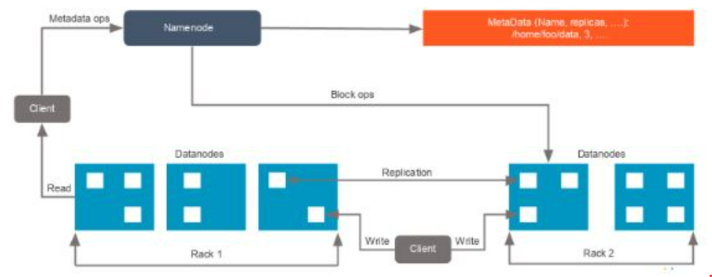
hdfs-architecture

For an HDFS service, we have a Name Node that has the master process running on one of the machines and Data Nodes, which are the slave nodes.

Name Node
Name Node is the master service that hosts metadata in disk and RAM. It holds information about the various Data Nodes, their location, the size of each block, etc.

Data Node
Data Nodes hold the actual data blocks and send block reports to the Name Node every 10 seconds. The Data Node stores and retrieves the blocks when the Name Node asks. It reads and writes the client’s request and performs block creation, deletion, and replication based on instructions from the Name Node.

Data that is written to HDFS is split into blocks, depending on its size. The blocks are randomly distributed across the nodes. With the auto-replication feature, these blocks are auto-replicated across multiple machines with the condition that no two identical blocks can sit on the same machine.
As soon as the cluster comes up, the Data Nodes start sending their heartbeats to the Name Nodes every three seconds. The Name Node stores this information; in other words, it starts building metadata in RAM, which contains information about the Data Nodes available in the beginning. This metadata is maintained in RAM, as well as in the disk.
7. What are the two types of metadata that a Name Node server holds?
The two types of metadata that a Name Node server holds are:
Metadata in Disk - This contains the edit log and the FSImage
Metadata in RAM - This contains the information about Data Nodes
8. What is the difference between a federation and high availability?
HDFS Federation
HDFS High Availability
There is no limitation to the number of NameNodes and the NameNodes are not related to each other
All the NameNodes share a pool of metadata in which each NameNode will have its dedicated pool
Provides fault tolerance, i.e., if one NameNode goes down, it will not affect the data of the other NameNode
There are two NameNodes that are related to each other. Both active and standby NameNodes work all the time
One at a time, active NameNodes will be up and running, while standby NameNodes will be idle and updating its metadata once in a while
It requires two separate machines. First, the active Name Node will be configured, while the secondary Name Node will be configured on the other system
9. If you have an input file of 350 MB, how many input splits would HDFS create and what would be the size of each input split?
By default, each block in HDFS is divided into 128 MB. The size of all the blocks, except the last block, will be 128 MB. For an input file of 350 MB, there are three input splits in total. The size of each split is 128 MB, 128MB, and 94 MB.
10. How does rack awareness work in HDFS?
HDFS Rack Awareness refers to the knowledge of different Data Nodes and how it is distributed across the racks of a Hadoop Cluster.
By default, each block of data is replicated three times on various Data Nodes present on different racks. Two identical blocks cannot be placed on the same Data Node. When a cluster is “rack-aware,” all the replicas of a block cannot be placed on the same rack. If a Data Node crashes, you can retrieve the data block from different Data Nodes.
11. How can you restart Name Node and all the daemons in Hadoop?
The following commands will help you restart Name Node and all the daemons:
You can stop the Name Node with ./sbin /Hadoop-daemon.sh stop Name Node command and then start the Name Node using ./sbin/Hadoop-daemon.sh start Name Node command.
You can stop all the daemons with ./sbin /stop-all.sh command and then start the daemons using the ./sbin/start-all.sh command.
12. Which command will help you find the status of blocks and Filesystem health?
To check the status of the blocks, use the command:
hdfs fsck <path> -files -blocks
To check the health status of Filesystem, use the command:

hdfs fsck / -files –blocks –locations > dfs-fsck.log
13. What would happen if you store too many small files in a cluster on HDFS?
Storing several small files on HDFS generates a lot of metadata files. To store these metadata in the RAM is a challenge as each file, block, or directory takes 150 bytes for metadata. Thus, the cumulative size of all the metadata will be too large.
14. How do you copy data from the local system onto HDFS?
The following command will copy data from the local file system onto HDFS:
hadoop fs –copyFromLocal [source] [destination]
Example: hadoop fs –copyFromLocal /tmp/data.csv /user/test/data.csv

In the above syntax, the source is the local path and destination is the HDFS path. Copy from the local system using a -f option (flag option), which allows you to write the same file or a new file to HDFS.

15. When do you use the dfsadmin -refreshNodes and rmadmin -refreshNodes commands?
The commands below are used to refresh the node information while commissioning, or when the decommissioning of nodes is completed.
dfsadmin -refreshNodes
This is used to run the HDFS client and it refreshes node configuration for the NameNode.
rmadmin -refreshNodes
This is used to perform administrative tasks for ResourceManager.

16. Is there any way to change the replication of files on HDFS after they are already written to HDFS?
Yes, the following are ways to change the replication of files on HDFS:
We can change the dfs.replication value to a particular number in the $HADOOP_HOME/conf/hadoop-site.xml file, which will start replicating to the factor of that number for any new content that comes in.
If you want to change the replication factor for a particular file or directory, use:
$HADOOP_HOME/bin/Hadoop dfs –setrep –w4 /path of the file
Example: $HADOOP_HOME/bin/Hadoop dfs –setrep –w4 /user/temp/test.csv

17. Who takes care of replication consistency in a Hadoop cluster and what do under/over replicated blocks mean?
In a cluster, it is always the Name Node that takes care of the replication consistency. The fsck command provides information regarding the over and under-replicated block.
Under-replicated blocks:
These are the blocks that do not meet their target replication for the files they belong to. HDFS will automatically create new replicas of under-replicated blocks until they meet the target replication.
Consider a cluster with three nodes and replication set to three. At any point, if one of the Name Nodes crashes, the blocks would be under-replicated. It means that there was a replication factor set, but there are not enough replicas as per the replication factor. If the Name Node does not get information about the replicas, it will wait for a limited amount of time and then start the re-replication of missing blocks from the available nodes.

Over-replicated blocks:
These are the blocks that exceed their target replication for the files they belong to. Usually, over-replication is not a problem, and HDFS will automatically delete excess replicas.
Consider a case of three nodes running with the replication of three, and one of the nodes goes down due to a network failure. Within a few minutes, the Name Node re-replicates the data, and then the failed node is back with its set of blocks. This is an over-replication situation, and the Name Node will delete a set of blocks from one of the nodes.
18. What is the distributed cache in MapReduce?
A distributed cache is a mechanism wherein the data coming from the disk can be cached and made available for all worker nodes. When a MapReduce program is running, instead of reading the data from the disk every time, it would pick up the data from the distributed cache to benefit the MapReduce processing.

To copy the file to HDFS, you can use the command:
hdfs dfs-put /user/Simplilearn/lib/jar_file.jar
To set up the application’s JobConf, use the command:
DistributedCache.addFileToClasspath(newpath(“/user/Simplilearn/lib/jar_file.jar”), conf)

Then, add it to the driver class.

Get Real-World Ready With Purdue University & IBM!
Data Engineering Certification ProgramEXPLORE PROGRAMGet Real-World Ready With Purdue University & IBM!
19. What role do Record Reader, Combiner, and Partitioner play in a MapReduce operation?
Record Reader
This communicates with the InputSplit and converts the data into key-value pairs suitable for the mapper to read.

Combiner
This is an optional phase; it is like a mini reducer. The combiner receives data from the map tasks, works on it, and then passes its output to the reducer phase.

Partitioner
The partitioner decides how many reduced tasks would be used to summarize the data. It also confirms how outputs from combiners are sent to the reducer, and controls the partitioning of keys of the intermediate map outputs.

20. Why is MapReduce slower in processing data in comparison to other processing frameworks?
This is quite a common question in Hadoop interviews; let us understand why MapReduce is slower in comparison to the other processing frameworks:

MapReduce is slower because:
It is batch-oriented when it comes to processing data. Here, no matter what, you would have to provide the mapper and reducer functions to work on data.
During processing, whenever the mapper function delivers an output, it will be written to HDFS and the underlying disks. This data will be shuffled and sorted, and then be picked up for the reducing phase. The entire process of writing data to HDFS and retrieving it from HDFS makes MapReduce a lengthier process.
In addition to the above reasons, MapReduce also uses Java language, which is difficult to program as it has multiple lines of code.

21. Is it possible to change the number of mappers to be created in a MapReduce job?
By default, you cannot change the number of mappers, because it is equal to the number of input splits. However, there are different ways in which you can either set a property or customize the code to change the number of mappers.

For example, if you have a 1GB file that is split into eight blocks (of 128MB each), there will only be only eight mappers running on the cluster. However, there are different ways in which you can either set a property or customize the code to change the number of mappers.

22. Name some Hadoop-specific data types that are used in a MapReduce program.
This is an important question, as you would need to know the different data types if you are getting into the field of Big Data.

For every data type in Java, you have an equivalent in Hadoop. Therefore, the following are some Hadoop-specific data types that you could use in your MapReduce program:

IntWritable
FloatWritable
LongWritable
DoubleWritable
BooleanWritable
ArrayWritable
MapWritable
ObjectWritable

23. What is speculative execution in Hadoop?
If a Data Node is executing any task slowly, the master node can redundantly execute another instance of the same task on another node. The task that finishes first will be accepted, and the other task would be killed. Therefore, speculative execution is useful if you are working in an intensive workload kind of environment.
The following image depicts the speculative execution:
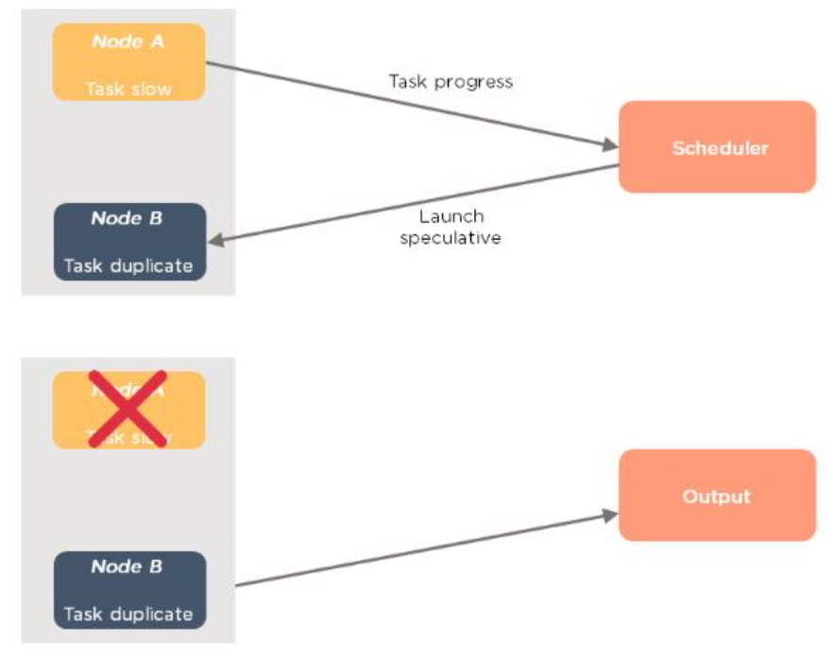
From the above example, you can see that node A has a slower task. A scheduler maintains the resources available, and with speculative execution turned on, a copy of the slower task runs on node B. If node A task is slower, then the output is accepted from node B.

24. How is identity mapper different from chain mapper?
Identity Mapper | Chain Mapper
This is the default mapper that is chosen when no mapper is specified in the MapReduce driver class. | This class is used to run multiple mappers in a single map task.
It implements identity function, which directly writes all its key-value pairs into output. | The output of the first mapper becomes the input to the second mapper, second to third and so on.
It is defined in old MapReduce API (MR1) in: org.apache.Hadoop.mapred.lib.package | It is defined in: org.apache.Hadoop.mapreduce.lib.chain.ChainMapperpackage
25. What are the major configuration parameters required in a MapReduce program?
We need to have the following configuration parameters:
- Input location of the job in HDFS
- Output location of the job in HDFS
- Input and output formats
- Classes containing a map and reduce functions
- JAR file for mapper, reducer and driver classes
26. What do you mean by map-side join and reduce-side join in MapReduce?
Map-side join | Reduce-side join
The mapper performs the join | The reducer performs the join
Each input data must be divided into the same number of partitions | Easier to implement than the map side join, as the sorting and shuffling phase sends the value with identical keys to the same reducer
Input to each map is in the form of a structured partition and is in sorted order | No need to have the dataset in a structured form (or partitioned)

27. What is the role of the Output Committer class in a MapReduce job?
As the name indicates, Output Committer describes the commit of task output for a MapReduce job.
Example: org.apache.hadoop.mapreduce.OutputCommitter
public abstract class OutputCommitter extends Output Committer
MapReduce relies on the Output Committer for the following:
- Set up the job initialization
- Cleaning up the job after the job completion
- Set up the task’s temporary output
- Check whether a task needs a commit
- Committing the task output
- Discard the task commit
28. Explain the process of spilling in MapReduce.
Spilling is a process of copying the data from memory buffer to disk when the buffer usage reaches a specific threshold size. This happens when there is not enough memory to fit all of the mapper output. By default, a background thread starts spilling the content from memory to disk after 80 percent of the buffer size is filled.

For a 100 MB size buffer, the spilling will start after the content of the buffer reaches a size of 80 MB.

29. How can you set the mappers and reducers for a MapReduce job?
The number of mappers and reducers can be set in the command line using:
-D mapred.map.tasks=5 –D mapred.reduce.tasks=2

In the code, one can configure JobConf variables:
job.setNumMapTasks(5); // 5 mappers
job.setNumReduceTasks(2); // 2 reducers

30. What happens when a node running a map task fails before sending the output to the reducer?
If this ever happens, map tasks will be assigned to a new node, and the entire task will be rerun to re-create the map output. In Hadoop v2, the YARN framework has a temporary daemon called application master, which takes care of the execution of the application. If a task on a particular node failed due to the unavailability of a node, it is the role of the application master to have this task scheduled on another node.
31. Can we write the output of MapReduce in different formats?
Yes. Hadoop supports various input and output File formats, such as:
TextOutputFormat - This is the default output format and it writes records as lines of text.
SequenceFileOutputFormat - This is used to write sequence files when the output files need to be fed into another MapReduce job as input files.
MapFileOutputFormat - This is used to write the output as map files.
SequenceFileAsBinaryOutputFormat - This is another variant of SequenceFileInputFormat. It writes keys and values to a sequence file in binary format.
DBOutputFormat - This is used for writing to relational databases and HBase. This format also sends the reduce output to a SQL table.
32. What benefits did YARN bring in Hadoop 2.0 and how did it solve the issues of MapReduce v1?
In Hadoop v1, MapReduce performed both data processing and resource management; there was only one master process for the processing layer known as Job Tracker. Job Tracker was responsible for resource tracking and job scheduling.
Managing jobs using a single Job Tracker and utilization of computational resources was inefficient in MapReduce 1. As a result, Job Tracker was overburdened due to handling, job scheduling, and resource management. Some of the issues were scalability, availability issue, and resource utilization. In addition to these issues, the other problem was that non-MapReduce jobs couldn’t run in v1.

To overcome this issue, Hadoop 2 introduced YARN as the processing layer. In YARN, there is a processing master called ResourceManager. In Hadoop v2, you have ResourceManager running in high availability mode. There are node managers running on multiple machines, and a temporary daemon called application master. Here, the ResourceManager is only handling the client connections and taking care of tracking the resources.

In Hadoop v2, the following features are available:
Scalability - You can have a cluster size of more than 10,000 nodes and you can run more than 100,000 concurrent tasks.
Compatibility - The applications developed for Hadoop v1 run on YARN without any disruption or availability issues.
Resource utilization - YARN allows the dynamic allocation of cluster resources to improve resource utilization.
Multitenancy - YARN can use open-source and proprietary data access engines, as well as perform real-time analysis and run ad-hoc queries.
Free Course: Getting Started with Hadoop
Learn the Fundamentals of HadoopENROLL NOWFree Course: Getting Started with Hadoop
33. Explain how YARN allocates resources to an application with the help of its architecture.
There is a client/application/API which talks to ResourceManager. The ResourceManager manages the resource allocation in the cluster. It has two internal components, scheduler, and application manager. The ResourceManager is aware of the resources that are available with every node manager. The scheduler allocates resources to various running applications when they are running in parallel. It schedules resources based on the requirements of the applications. It does not monitor or track the status of the applications.

Applications Manager is what accepts job submissions. It monitors and restarts the application masters in case of failures. Application Master manages the resource needs of individual applications. It interacts with the scheduler to acquire the required resources, and with NodeManager to execute and monitor tasks, which tracks the jobs running. It monitors each container’s resource utilization.
A container is a collection of resources, such as RAM, CPU, or network bandwidth. It provides the rights to an application to use a specific number of resources.
Let us have a look at the architecture of YARN:
nodemanager.
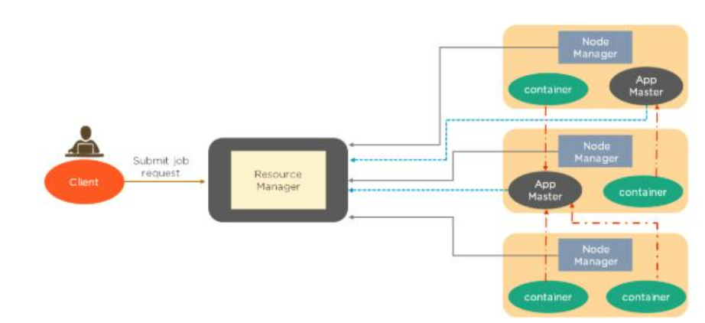
Whenever a job submission happens, ResourceManager requests the NodeManager to hold some resources for processing. NodeManager then guarantees the container that would be available for processing. Next, the ResourceManager starts a temporary daemon called application master to take care of the execution. The App Master, which the applications manager launches, will run in one of the containers. The other containers will be utilized for execution. This is briefly how YARN takes care of the allocation.

34. Which of the following has replaced JobTracker from MapReduce v1?
- NodeManager
- ApplicationManager
- ResourceManager
- Scheduler
The answer is Resource Manager. It is the name of the master process in Hadoop v2.

35. Write the YARN commands to check the status of an application and kill an application.
The commands are as follows:

a) To check the status of an application:
yarn application -status ApplicationID

b) To kill or terminate an application:
yarn application -kill ApplicationID

36. Can we have more than one Resource Manager in a YARN-based cluster?
Yes, Hadoop v2 allows us to have more than one ResourceManager. You can have a high availability YARN cluster where you can have an active ResourceManager and a standby ResourceManager, where the ZooKeeper handles the coordination.
There can only be one active ResourceManager at a time. If an active ResourceManager fails, then the standby ResourceManager comes to the rescue.

37. What are the different schedulers available in YARN?
The different schedulers available in YARN are:
FIFO scheduler - These places applications in a queue and runs them in the order of submission (first in, first out). It is not desirable, as a long-running application might block the small running applications
Capacity scheduler - A separate dedicated queue allows the small job to start as soon as it is submitted. The large job finishes later compared to using the FIFO scheduler
Fair scheduler - There is no need to reserve a set amount of capacity since it will dynamically balance resources between all the running jobs
38. What happens if a ResourceManager fails while executing an application in a high availability cluster?
In a high availability cluster, there are two ResourceManagers: one active and the other standby. If a ResourceManager fails in the case of a high availability cluster, the standby will be elected as active and instructs the ApplicationMaster to abort. The ResourceManager recovers its running state by taking advantage of the container statuses sent from all node managers.

39. In a cluster of 10 DataNodes, each having 16 GB RAM and 10 cores, what would be the total processing capacity of the cluster?
Every node in a Hadoop cluster will have one or multiple processes running, which would need RAM. The machine itself, which has a Linux file system, would have its own processes that need a specific amount of RAM usage. Therefore, if you have 10 DataNodes, you need to allocate at least 20 to 30 percent towards the overheads, Cloudera-based services, etc. You could have 11 or 12 GB and six or seven cores available on every machine for processing. Multiply that by 10, and that's your processing capacity.

40. What happens if requested memory or CPU cores go beyond the size of container allocation?
If an application starts demanding more memory or more CPU cores that cannot fit into a container allocation, your application will fail. This happens because the requested memory is more than the maximum container size.
Now that you have learned about HDFS, MapReduce, and YARN, let us move to the next section. We’ll go over questions about Hive, Pig, HBase, and Sqoop.

Hadoop Interview Questions - HIVE
41. What are the different components of a Hive architecture?
The different components of the Hive are:
User Interface: This calls the execute interface to the driver and creates a session for the query. Then, it sends the query to the compiler to generate an execution plan for it
Metastore: This stores the metadata information and sends it to the compiler for the execution of a query
Compiler: This generates the execution plan. It has a DAG of stages, where each stage is either a metadata operation, a map, or reduces a job or operation on HDFS
Execution Engine: This acts as a bridge between the Hive and Hadoop to process the query. Execution Engine communicates bidirectionally with Metastore to perform operations, such as create or drop tables.
42. What is the difference between an external table and a managed table in Hive?
External Table | Managed Table
External tables in Hive refer to the data that is at an existing location outside the warehouse directory | Also known as the internal table, these types of tables manage the data and move it into its warehouse directory by default
Hive deletes the metadata information of a table and does not change the table data present in HDFS | If one drops a managed table, the metadata information along with the table data is deleted from the Hive warehouse directory

43. What is a partition in Hive and why is partitioning required in Hive
Partition is a process for grouping similar types of data together based on columns or partition keys. Each table can have one or more partition keys to identify a particular partition.
Partitioning provides granularity in a Hive table. It reduces the query latency by scanning only relevant partitioned data instead of the entire data set. We can partition the transaction data for a bank based on month — January, February, etc. Any operation regarding a particular month, say February, will only have to scan the February partition, rather than the entire table data.
44. Why does Hive not store metadata information in HDFS?
We know that the Hive’s data is stored in HDFS. However, the metadata is either stored locally or it is stored in RDBMS. The metadata is not stored in HDFS, because HDFS read/write operations are time-consuming. As such, Hive stores metadata information in the metastore using RDBMS instead of HDFS. This allows us to achieve low latency and is faster.
45. What are the components used in Hive query processors?
The components used in Hive query processors are:
- Parser
- Semantic Analyzer
- Execution Engine
- User-Defined Functions
- Logical Plan Generation
- Physical Plan Generation
- Optimizer
- Operators
- Type checking
46. Suppose there are several small CSV files present in /user/input directory in HDFS and you want to create a single Hive table from these files. The data in these files have the following fields: {registration_no, name, email, address}. What will be your approach to solve this, and where will you create a single Hive table for multiple smaller files without degrading the performance of the system?
Using SequenceFile format and grouping these small files together to form a single sequence file can solve this problem. Below are the steps:
>read.table(file = ''data.table",header = TRUE)
ID Name Age Gender
1 Amit 23 male
2 Varun 18 female
3 Rohit 21 male
4 Sumit 25 female

47. Write a query to insert a new column(new_col INT) into a hive table (h_table) at a position before an existing column (x_col).
The following query will insert a new column:
ALTER TABLE h_table
CHANGE COLUMN new_col INT
BEFORE x_col

48. What are the key differences between Hive and Pig?
Hive | Pig
It uses a declarative language, called HiveQL, which is like SQL for reporting. | Uses a high-level procedural language called Pig Latin for programming
Operates on the server-side of the cluster and allows structured data. | Operates on the client-side of the cluster and allows both structured and unstructured data
It does not support the Avro file format by default. This can be done using “Org.Apache. Hadoop.Hive. serde2.Avro” | Supports Avro file format by default.
Facebook developed it and it supports partition | Yahoo developed it, and it does not support partition

49. How is Apache Pig different from MapReduce?
Pig | MapReduce
It has fewer lines of code compared to MapReduce. | Has more lines of code.
A high-level language that can easily perform join operation. | A low-level language that cannot perform join operation easily.
On execution, every Pig operator is converted internally into a MapReduce job | MapReduce jobs take more time to compile.
Works with all versions of Hadoop | A MapReduce program written in one Hadoop version may not work with other versions

50. What are the different ways of executing a Pig script?
The different ways of executing a Pig script are as follows:
- Grunt shell
- Script file
- Embedded script
51. What are the major components of a Pig execution environment?
The major components of a Pig execution environment are:
Pig Scripts: They are written in Pig Latin using built-in operators and UDFs, and submitted to the execution environment.
Parser: Completes type checking and checks the syntax of the script. The output of the parser is a Directed Acyclic Graph (DAG).
Optimizer: Performs optimization using merge, transform, split, etc. Optimizer aims to reduce the amount of data in the pipeline.
Compiler: Converts the optimized code into MapReduce jobs automatically.
Execution Engine: MapReduce jobs are submitted to execution engines to generate the desired results.
52. Explain the different complex data types in Pig.
Pig has three complex data types, which are primarily Tuple, Bag, and Map.
Tuple
A tuple is an ordered set of fields that can contain different data types for each field. It is represented by braces ().
Example: (1,3)
Bag
A bag is a set of tuples represented by curly braces {}.
Example: {(1,4), (3,5), (4,6)}
Map
A map is a set of key-value pairs used to represent data elements. It is represented in square brackets [ ].
Example: [key#value, key1#value1,….]
53. What are the various diagnostic operators available in Apache Pig?
Pig has Dump, Describe, Explain, and Illustrate as the various diagnostic operators.
Dump
The dump operator runs the Pig Latin scripts and displays the results on the screen.
Load the data using the “load” operator into Pig.
Display the results using the “dump” operator.

Describe
Describe operator is used to view the schema of a relation.
Load the data using “load” operator into Pig
View the schema of a relation using “describe” operator

Explain
Explain operator displays the physical, logical and MapReduce execution plans.
Load the data using “load” operator into Pig
Display the logical, physical and MapReduce execution plans using “explain” operator

Illustrate
Illustrate operator gives the step-by-step execution of a sequence of statements.
Load the data using “load” operator into Pig
Show the step-by-step execution of a sequence of statements using “illustrate” operator

54. State the usage of the group, order by, and distinct keywords in Pig scripts.
The group statement collects various records with the same key and groups the data in one or more relations.
Example: Group_data = GROUP Relation_name BY AGE

The order statement is used to display the contents of relation in sorted order based on one or more fields.

Example: Relation_2 = ORDER Relation_name1 BY (ASC|DSC)

Distinct statement removes duplicate records and is implemented only on entire records, and not on individual records.

Example: Relation_2 = DISTINCT Relation_name1

55. What are the relational operators in Pig?
The relational operators in Pig are as follows:
COGROUP
It joins two or more tables and then performs GROUP operation on the joined table result.
CROSS
This is used to compute the cross product (cartesian product) of two or more relations.
FOREACH
This will iterate through the tuples of a relation, generating a data transformation.
JOIN
This is used to join two or more tables in a relation.
LIMIT
This will limit the number of output tuples.
SPLIT
This will split the relation into two or more relations.
UNION
It will merge the contents of two relations.
ORDER
This is used to sort a relation based on one or more fields.

56. What is the use of having filters in Apache Pig?
Filter Operator is used to select the required tuples from a relation based on a condition. It also allows you to remove unwanted records from the data file.

Example: Filter the products with a whole quantity that is greater than 1000

A = LOAD ‘/user/Hadoop/phone_sales’ USING PigStorage(‘,’) AS (year:int, product:chararray, quantity:int);
B = FILTER A BY quantity > 1000
Mobile_data.dat
year, product,quantity
2000 mobile 20
2001 mobile 50
2002 mobile 30
2003 mobile 28
2004 mobile 40

57. Suppose there’s a file called “test.txt” having 150 records in HDFS. Write the PIG command to retrieve the first 10 records of the file.
To do this, we need to use the limit operator to retrieve the first 10 records from a file.
Load the data in Pig:
test_data = LOAD “/user/test.txt” USING PigStorage(‘,’) as (field1, field2,….);
Limit the data to first 10 records:
Limit_test_data = LIMIT test_data 10;

